PRESS RELEASE Ljubljana, 18 February 2025
Aïda Muluneh: On the Edge of Past Future
Exhibition by Fotografie Forum Frankfurt (FFF)
Jakopič Gallery, Ljubljana 25. 2.–1. 6. 2025
Guided tour for journalists: Tuesday, 25 February 2025, at 11 a.m.
Guided tour with the curator prof. Celina Lunsford (FFF): 25 February 2025 at 6 p.m.
Opening: 25 February 2025 at 7 p.m.
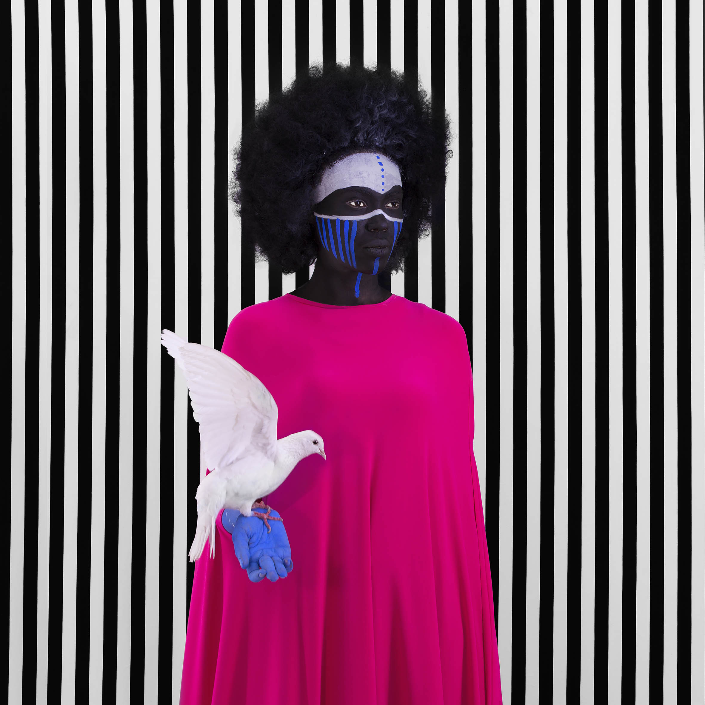
Compromise, 2017, from the series The Memory of Hope © Aïda Muluneh
The works of Aïda Muluneh are a testament to the transformative power of photography that challenges established narratives, sparking curiosity, and inspiring change. Her exhibition On the Edge of Past Future explores critical issues such as water scarcity, gender equality, and human resilience, while reimagining the visual language of Africa. The exhibition is produced by Fotografie Forum Frankfurt (FFF).
Full of symbolism, vibrant colours and bold patterns, the photographs of contemporary Ethiopian artist Aïda Muluneh (1974) aim to reflect and raise awareness. Through her exceptional visual language, the photographer's work highlights pressing global issues, while advocating for the empowerment of women and reimagining the visual language of Africa.
The exhibition On the Edge of Past Future not only showcases the artist’s remarkable expressive power but also supports the efforts of the Jakopič Gallery – strengthening awareness of the social significance of photography, the value of community, and the exploration of the extraordinary creative potential of geographic regions which are less known to us.
At the same time, the exhibition offers an exceptional opportunity for an accompanying programme that goes beyond folklore and clichéd thinking about Ethiopia and Africa, and opens up a broader social, intellectual and communal reflection on African culture and its original creative spirit.
You are warmly invited to the opening of the Aïda Muluneh: On the Edge of Past Future, which will begin with a guided tour by prof. Celina Lunsford, Artistic Director of Fotografie Forum Frankfurt and curator of the exhibition, at 6 p.m. on Tuesday, 25 February 2025 at Jakopič Gallery. The exhibition will be inaugurated at 7 p.m. by Mateja Demšič, MA, Head of Culture Department, City of Ljubljana.
MORE ABOUT THE EXHIBITION
The works of Aïda Muluneh are a testament to the transformative power of photography that challenges established narratives, sparking curiosity, and inspiring change. Her exhibition On the Edge of Past Future explores critical issues such as water scarcity, gender equality, and human resilience, while reimagining the visual language of Africa. The exhibition not only showcases the artist’s remarkable expressive power but also supports the efforts of the Jakopič Gallery – strengthening awareness of the social significance of photography, the value of community, and the exploration of the extraordinary creative potential of geographic regions which are less known to us.
The photographs are characterised by vibrant colours, symbolic compositions, and multilayered storytelling. Rooted in her Ethiopian heritage and global experiences, her works blend traditional African body painting with influences from cinema, painting, and photojournalism. Each photograph is carefully designed to provoke reflection and transcend the boundaries of conventional documentary or artistic photography.
The exhibition presents the most prominent series by Aïda Muluneh from the past decade. The Water Life (2018) illuminates the impact of water scarcity on women in rural Ethiopia through powerful portraits. Shot in the harsh landscapes of Dallol, the series symbolically highlights the burden of limited access to water and its consequences for health, education, and empowerment opportunities.
The Memory of Hope (2017) explores the fragility of hope in a world where passivity fosters ignorance and greed – through a reflection on our social responsibility, indifference, and the urgent need to confront the reality we (too) quickly overlook. In the series The World is 9 (2016), Aïda reflects on the unpredictability of life and human quest for balance amid imperfection. These works explore universal themes of love, identity, and resilience, while using surreal backgrounds and powerful symbols to pose provocative questions about our existence. The series The Road of Glory (2020), created for the Nobel Peace Center, examines the use of hunger as a weapon of war. These poignant photographs reveal the human cost of political agendas and highlight the resilience of those trapped in the vortex of systematic oppression.
The photographer also engages with the historical and cultural narratives of Africa. In the series The Distant Gaze (2017), she reinterprets archival photographs of Ethiopian and Eritrean women taken by foreign photographers during the colonial era, exploring the commodification and objectification of black female bodies. By reclaiming these depictions, she encourages reflection on contemporary representations of African women and their global resonance. In addition to her own creativity, the artist draws inspiration from poetry, such as Maya Angelou’s Woman Work (in the the Water Life series) and Emily Dickinson’s ‘Hope’ is the thing with feathers (in the Wings that Soar series). These literary influences infuse her photography with a universality that connects personal and collective struggles.
Aïda’s photographs extend beyond aesthetics, as they confront key issues with empathy and urgency. Her works invite viewers to explore the complexities of Africa beyond the clichés often presented in the media, encouraging a deeper understanding of its challenges and resilience. Through her art, Aïda reclaims the narrative of her homeland while addressing the global condition, reminding us of our interconnectedness and shared humanity.

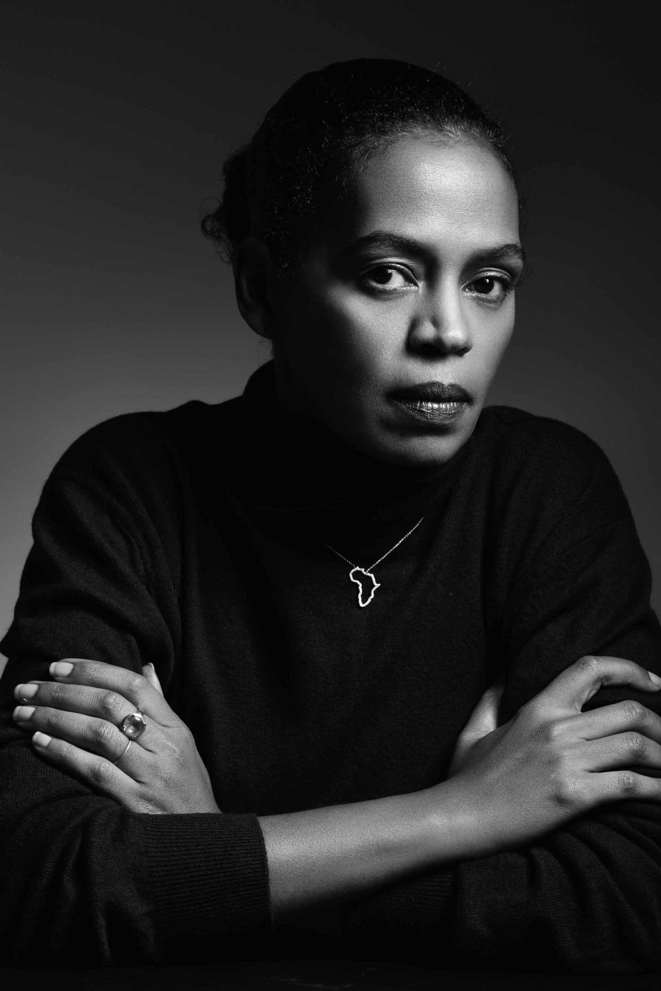
A SHORT BIO
Aïda Muluneh is a contemporary artist, photographer, photojournalist, educator and cultural entrepreneur, who is changing global perceptions of the African continent. Born in Addis Ababa in 1974, she left Ethiopia at an early age, when the country was in the midst of a devastating civil war. After living in different countries, she graduated from Howard University in Washington, D.C., with a degree in Communications, majoring in Film. Than she took a job at The Washington Post and began to question the mass media's attitude towards African Americans and the African continent. In 2019, she became the first black woman to co-curate the Nobel Peace Prize exhibition and returned the following year as a commissioned artist and created the series The Road of Glory for the Nobel Peace Center. As a prominent Canon brand ambassador, Muluneh is deeply committed to advocating for the development of photography in Africa through her educational programs across the continent. She is the founder of Addis Foto Fest, the first international photography festival in East Africa, held since 2010 in Addis Ababa, and the Africa Foto Fair, established in 2022 in Côte d’Ivoire, that brings emerging and established talents to the global photography community. Additionally, she established the Africa Print House in Abidjan—a creative space that provides end-to-end solutions for photographers in Africa. As an educator and cultural entrepreneur, she continues to develop projects with local and international institutions in Ethiopia and Côte d’Ivoire, where she currently lives. Her photography has been widely exhibited and published worldwide and is included in the permanent collections of prestigious institutions such as the Museum of Modern Art (MoMA), the Smithsonian’s National Museum of African Art, the Hood Museum, the RISD Museum of Art, and the Museum of Biblical Art (USA). Muluneh received the European Union Prize at the Rencontres Africaines de la Photographie in Bamako, Mali, in 2007, the CRAF International Award of Photography in Spilimbergo, Italy, in 2010, and was a CatchLight Fellow in San Francisco (USA), in 2018. In 2020, she was honored with the The Royal Photographic Society Award (Bristol, UK) in Curatorship.
Photo: Portrait of Aïda Muluneh by Mario Epanya
(More at: https://aidamuluneh.com)
ABOUT THE USE OF THE PHOTOS FROM THE PRESS MATERIAL:
Please notice, that just up to 5 photos from the official PRESS pack can be published in one media (printed or online). In accordance with the protection of copyright, we kindly ask you to publish all photographs for the media on the occasion of the Aïde Muluneh exhibition or photographs of Aïde Muluneh published on the websites of the Jakopič Gallery or the Museum and Galleries of Ljubljana (MGML) in their original version, without any alterations and without overlaying them with captions. We also ask that you consistently use captions and attributions.
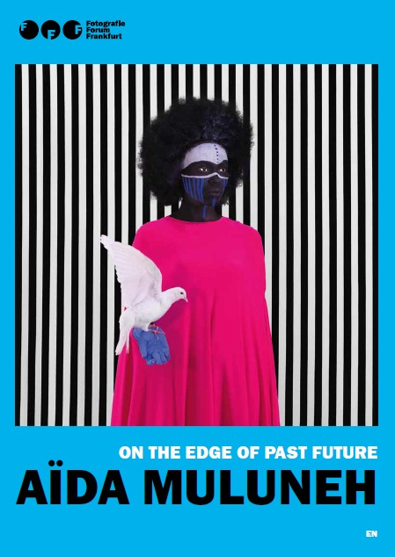
EXHIBITION MAGAZINE
Accompanying the exhibition Aïda Muluneh: On the Edge of Past Future, the Fotografie Forum Frankfurt (FFF) has produced a magazine, which includes a text by the curator Celine Lunsford (FFF), Aïda's own descriptions of the presented series and numerous reproductions of her photographs.
The publication will be on sale at the Jakopič Gallery, accompanied by Slovenian translations of the texts.
PROGRAMME ACCOMPANYING THE EXHIBITION
Guided tours in English: every Saturday at 4.30 p.m.
Guided tour by the curator Celina Lunsford (FFF) prior to the exhibition opening: 25. 2. 2025 at 6 p.m.

Expert guided tour of the exhibition with the curator of Jakopič Gallery: 18. 5. 2025 ob at 4.30 p.m. (International Museum Day) and 24. 5. at 4.30 p.m. (in English as part of Ljubljana Art Weekend)
Love through the lens of Aïde Muluneh (LUV fest), guided tour, focused on the manifold manifestations of love: 8. 3. 2025 at 4.30 p.m.
Online artist talk with Aïda Muluneh: 11. 3. 2025 at 6 p.m.
Foto aperitiv: Ethiopian literature and interpretation of Ethiopian music on percussion, with Jose & Damir Mazrek (in partnership with Divja misel): 2. 4. 2025 at 6 p.m

The 14th Africa Day International Conference: Art, Nature, and Sustainability: Rethinking Africa’s Resources Through Creativity. Interdisciplinary Round Table in cooperation with the Department for Africa and Middle East of Ministry of Foreign and European Affairs RS: 29. 4. 2025 at 6 p.m.
Lecture by Aleksandra Gačić about interweaving Ethiopian art and contemporary literature in the Imaginary of Aïda Muluneh: 7. 5. 2025 at 6 p.m.

Colophon
Photographer: Aïda Muluneh Produced by: Fotografie Forum Frankfurt (FFF), Dr. Marschner Stiftung, Hahnemühle Curators: Celina Lunsford, Andrea Horvay (FFF) Curators for Jakopič Gallery: Marija Skočir, Julija Hoda (MGML) Graphic design: Bojan Lazarevič (Agora Proars) Realisation of the exhibition: O.K.vir, Tehnična služba / Technical Service MGML Translations: Polonca Mesec Slovenian language editing: Katja Paladin Public relations: Maja Čehovin Korsika Accompanying programs: Aleksandra Gačić, Julija Hoda, Matevž Paternoster, Metod Blejec This project was made possible by: City of Ljubljana, Ministry of culture RS In partnership with: Ministry of Foreign and European Affairs RS, Divja misel, TAM-TAM

