PRESS RELEASE, Ljubljana, 9 June 2023
SUSAN MEISELAS: MEDIATIONS
Galerija Jakopič, 20. 6.–22. 10. 2023
You are warmly invited to the opening of the Susan Meiselas: Mediations exhibition, that will be introduced by a conversation with the photographer Susan Meiselas at 6 p.m. on Tuesday, 20 June 2023 in the Jakopič Gallery.
The exhibition will be inaugurated at 7 p.m. by H. E. Jamie Lindler Harpootlian, United States Ambassador to the Republic of Slovenia.

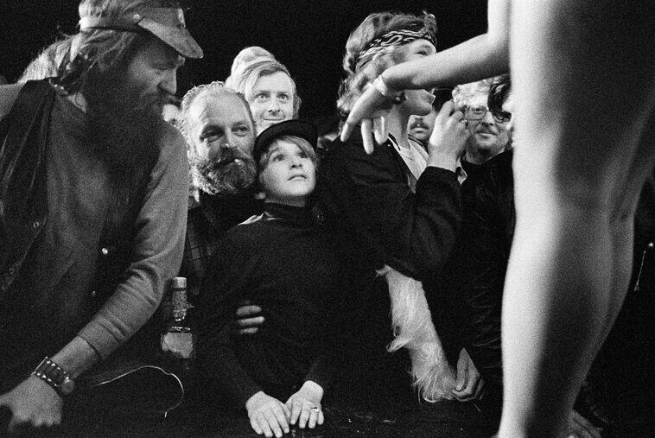
Before the show, Tunbridge, Vermont, USA, 1974 © Susan Meiselas / Magnum Photos
Susan Meiselas is a documentary photographer based in New York and a member of Magnum Photos since 1976. She creates works that raises provocative questions about documentary practice and the relationship between the photographer and the subject. The exhibition Mediations highlights her unique working method, which combines photography, video, sound and installation to explore different time scales and conflicts, from the personal to the geopolitical.

MORE ABOUT MEDIATIONS:
Susan Meiselas (US, 1948) has spent five decades using her camera to bear witness and connect. She has traveled across the globe and addressed a wide range of topics, from the sex industry to war to human rights violations. She returns repeatedly to many of her subjects, building relationships across time and telling stories on scales both personal and geopolitical. Her work has been propelled by urgent questions about not only what photographs show but also whom they serve.
Bringing together projects from the beginning of her career in the 1970s to the present day, this exhibition highlights Meiselas’s unique approach. While photography remains the artist’s primary medium, she has increasingly adopted other formats, including books, film, and sound recordings, to extend her photographic work and build narratives around it. Meiselas has also collected, published, and exhibited found images and documents as part of multimedia installations or online archives in order to include the voices of individuals and communities subject to violence and oppression.
This retrospective takes its name from a featured installation that critically re-examines the pictures Meiselas made during the popular insurrection in Nicaragua in 1978 and 1979. It raises provocative questions about how images are created, used, and perceived in different contexts and historical moments. It is precisely this critical attitude, also towards her own work, that makes her contribution to contemporary photography so invaluable.
Meiselas's early series, 44 Irving Street, captures residents of her boarding house through intimate portraits. Prince Street Girls documents the photographer's long-term bond with neighborhood children in New York. Porch Portraits portrays South Carolina residents in front of their homes, while Carnival Strippers explores the lives of women in carnival shows.
Another installation, The Life of an Image: Molotov Man, traces the impact of an iconic Nicaraguan revolution photograph. The ongoing project Kurdistan compiles a visual history of the Kurdish people, combining Meiselas's photographs with collected materials. The akaKURDISTAN online platform serves as a collective memory space for the Kurdish diaspora.
To raise awareness of domestic violence, Meiselas created Archives of Abuse, exhibiting collages of police reports and crime scene photos as bus shelter posters in San Francisco. In her later work, A Room of Their Own, Meiselas collaborated with women survivors, combining photographs, testimonials, and collages to capture the uniqueness of each room and create a lasting memory of a specific landscape.
This retrospective illuminates Meiselas's invaluable contribution to contemporary photography through her critical approach and commitment to amplifying marginalized voices.
A SHORT BIOGRAPHY:
Susan Meiselas (USA, 1948), one of the world's most socially engaged and conscious photographers, is a member of the Magnum Agency and a president of Magnum Foundation. She has been using her camera to witness and connect for the past five decades. In her early career, she has worked as a teacher in New York City and organized photography workshops for rural schools in the American South. She travelled to Nicaragua and later to El Salvador during the worst civil wars in those countries. In the following decades, she continued to get involved in various communities and conflicts around the world. Meiselas has travelled the world covering topics ranging from the sex industry to war and human rights violations. She draws attention to minorities and conflicts that are often overlooked. She always seeks direct contact and dialogue with the people she portrays. Her approach is collaborative and includes the perspective of the people she photographs. That is why she has proposed to hold the workshop described above on the occasion of her exhibition at the Jakopič Gallery in Ljubljana.
More about Susan Meiselas: https://www.susanmeiselas.com/
MASTERCLASS WITH SUSAM MEISELAS IN LJUBLJANA:
This retrospective Mediations illuminates Meiselas's invaluable contribution to contemporary photography through her critical approach and commitment to amplifying marginalized voices.
Besides, at the occasion of its presentation in Ljubljana she also initiated and co-mentored a masterclass called Photography Empowers for photographers and communities based in Slovenia. This initiative was undertaken with the goal of enhancing both Susan Meiselas's and Jakopič Gallery's comprehension of the profound social impact that photography carries in the contemporary world.
PROGRAMME ACCOMPANYING THE EXHIBITION
Photography Empowers
A two-day masterclass with Susan Meiselas and distinguished photography professionals Lydia Matthews and Luciana Pinchiero.
17 and 18 June 2023, 10 a.m. to 6 p.m.
Participants only.
Artists Talk with Susan Meiselas
20. 6. 2023 at 6 p.m.
Admission free.
COLOPHON
Production: Museum and Galleries of Ljubljana, Magnum PhotosPhotographer: Susan MeiselasCurator (Galerija Jakopič): dr. Marija SkočirStudio Manager (Susan Meiselas Studio): Luciana PinchieroExpert support (Galerija Jakopič): Julija HodaCo-creators: Carles Guerra (former Director of Fundació Antoni Tàpies, Barcelona), Marta Gili (former Director of Jeu de Paume, Paris)With thanks to: Andréa Holzherr (Magnum Photos)Graphic and exhibition design: Bojan Lazarevič (Agora Proars)Exhibition production: Technical Service MGML, O.K.virLanguage editing (Slovenian): Katja PaladinPublic relations and editing: Maja Čehovin KorsikaProgrammes: Metod Blejec, Julija Hoda, Matevž Paternoster, Janja ReboljThis project was made possible by: Mestna občina Ljubljana, Ministry of culture RSThe project was supported by: U.S. Embassy in SloveniaMedia sponsor: TAM-TAM, Europlakat
A WARNING ABOUT THE PUBLICATION OF PR PHOTOS:
In accordance with copyright protection, we kindly ask to publish all the photographs from the Susan Meiselas press pack or photographs about the exhibition and the photographer published on the GJ/MGML website in their original version, without any alterations and without overlaying them with captions. We also ask that you use captions and attribution consistently.

