Ljubljana, Friday, 22 January 2021

PRESS RELEASE

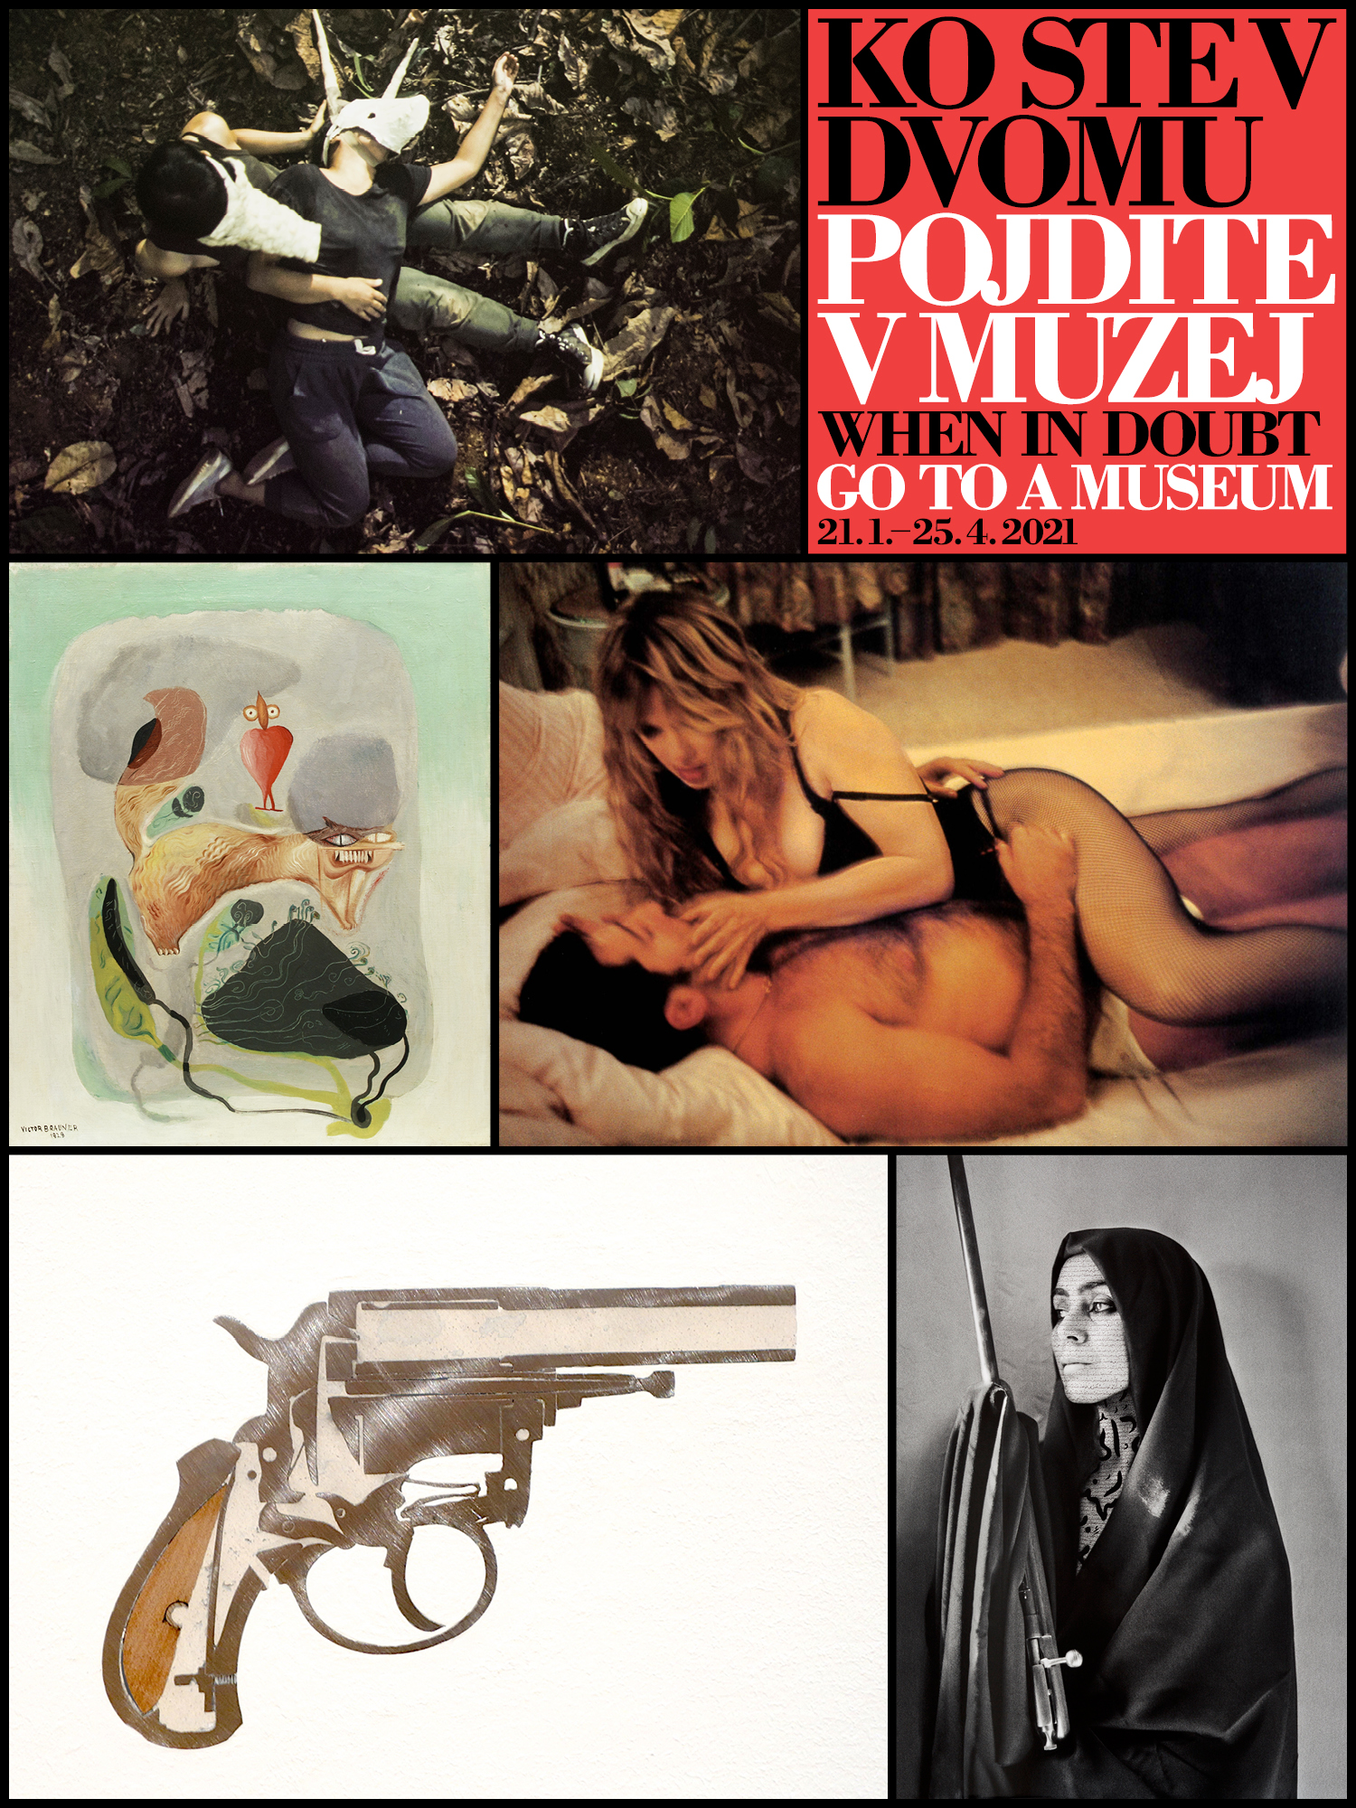
Starting Tuesday, 26 January 2021, when the City Museum of Ljubljana reopens at 10 a.m., an exhibition with the telling title, When in Doubt, Go to a Museum, will run. The exhibition features over 100 internationally renowned artworks, from five private collections, created from the 19th century to the present day. The show not only provides insight into the development of fine arts but also offers an excellent opportunity for observing a wide array of artistic practices that reflect the social changes of the previous 150 years.

The exhibition, which is a once-off project curated by Tevž Logar, will also help a more interested visitor to find answers to questions as to what the art system today is, how it works, and who its stakeholders are – creators, artworks, museums, private galleries, art collectors.

Part of the show is a room where the documentation relating to the five collections is presented. A catalogue will be published, and a conference will be held. Film screenings, performances, and guided tours are planned for when museums will be fully open. The exhibition layout and its graphic image are the work of Novi kolektivizem.

As no proper opening is possible for the time being, you are invited to view the online opening (link), with Blaž Peršin, Director of the Museum and Galleries of Ljubljana, and Tevž Logar. They were joined by all five of the collectors who have created the collections on display.

In his introductory remarks to the catalogue, which is due to appear during the exhibition, Blaž Peršin, who acted as project manager, wrote: “The Museum and Galleries of Ljubljana (MGML) has been considering collaboration with the curator Tevž Logar in this project for some time, in particular, because the practice of collecting contemporary art in Slovenia is insufficiently developed. Not only is there a lack of private galleries that focus on the sale of high-quality artworks of domestic and international production and on the related programmes, but there are extremely few collectors with a vision and solid conceptual starting points. This project aims to attract the attention of the Slovenian public and let the future art collectors know how important their position and passion are in creating possibilities for developing new strategies in this field.”

Those participating in the art system are increasingly aware that there is no point in ‘hiding’ an artwork at home. It is much better to make it seen and, even better, to make it part of various activities of society at large. In this way, the artwork and the collection increase their symbolic value and, as a result, even their economic value. An artwork’s spread and visibility add to its value. When designing this project, which introduces a new practice in Slovenia, Tevž Logar invited five private initiatives whose public activities and programmes linked with a collection disseminate knowledge and address the general public. They include Collection Laurent Fiévet, Lah Contemporary, Ovidiu Șandor Collection, Fondazione Sandretto Re Rebaudengo, and Thyssen-Bornemisza Art Contemporary Collection (TBA21).

Tevž Logar, the exhibition curator, briefly described the project: “The When in Doubt, Go to a Museum exhibition joins five collections into a coherent unit. What is presented are five case studies: in dialogue with the collections, I'm trying to analyse their specifics and present their related activities. Differing from other exhibitions typically designed to present an individual collection, the current project is unique in that it brings together several collections. The collectors view this as an interesting feature and a challenge simultaneously: the initiative to connect is an extremely important aspect in the present ‘COVID situation’. Both for our society and the art world.”

Apart from providing insight into how the international fine arts evolve, the exhibition also aims to answer the following questions: What is the role of the collector? How should the collector pursue the social significance of his or her collection? Who is the contemporary collector? The project aims to attract the attention of the general public and future collectors to contemporary artistic practices. This is also one way in which the Museum and Galleries of Ljubljana pursue the objective of forming alliances for the new multidisciplinary space of Cukrarna, which is scheduled to open this year.

The Novi kolektivizem group, on their starting points in designing the exhibition: “The exhibition layout draws on the fact that some of the exhibited collections feature distinct typographies and colours. These characteristics informed both the marking of the individual collections presented in different exhibition spaces of the City Museum of Ljubljana and the overall graphic image of the show along with all the advertising elements. As in the framework of contemporary art it is often difficult to distinguish between artefact and document, the documentation room featuring saturated colours drawn from the collections is similarly divided into virtual rooms. In this way, it not only has documentary value but can also be seen as an installation.”

Visiting the City Museum of Ljubljana during the Red and Orange Phases:
The City Museum of Ljubljana strictly adheres to the measures for prevention of the spread of COVID-19. The number of visitors to the museum will therefore be limited to 50; guided tours will be organised for a limited number of visitors or groups belonging to the same household.

Exhibited artists by Collections:
Collection Laurent Fiévet
Helena Almeida, Carl Andre, Diane Arbus, Mercedes Azpilicueta, Oliver Beer, Anna Betbeze, Etienne Chambaud, Jean Cocteau, Daniel Gustav Cramer, Rodolphe Delaunay, Dominique Gonzalez-Foerster, Laurent Grasso, Richard Hamilton, Pierre Huyghe, Jean-Louis Igout, Alexandre Lavet, Henri Matisse, Wilfredo Prieto, Anri Sala, unknown amateur photographer, Andy Warhol, Ian Whittlesea.

Lah Contemporary
Joseph Beuys, Sophie Calle, Ištvan Išt Huzjan, William Kentridge, Robert Mapplethorpe, Shirin Neshat, Marjetica Potrč, Hito Steyerl.

Ovidiu Șandor Collection
Dragos Alexandrescu, Jean Arp, Ştefan Bertalan, Constantin Brâncuși, Brassaï, Geta Brătescu, Victor Brauner, André Cadere, Ion Călugăru, Constantin Flondor, F. Brunea-Fox, Harun Farocki & Andrei Ujică, Ion Grigorescu, Marcel Iancu, Wassily Kandinsky, Gherasim Luca, Ana Lupaș, Victor Man, Max Hermann Maxy, Alex Mirutziu, Ciprian Muresan, Vlad Nanca, Paul Neagu, Ioana Nemes, Mihai Olos, Sașa Pană, Paul Păun, Jules Perahim, Eugen Rosca, Arthur Segal, Doru Tulcan, Tristan Tzara, Andra Ursuţa, Ilarie Voronca.

Fondazione Sandretto Re Rebaudengo
Maurizio Cattelan, Nan Goldin, Mona Hatoum, Josh Kline, Barbara Kruger, Yong-Baek Lee, Eva Marisaldi, Paulina Olowska, Raymond Pettibon.

Thyssen-Bornemisza Art Contemporary Collection (TBA21)
Dana Awartani, Christian Salablanca Díaz, freq_wave curated by Carl Michael von Hausswolff, Yeo Siew Hua, Eduardo Navarro.

COLOPHON
When in Doubt, Go in a Museum
21. 1. 2021–25. 4. 2021
Museum and Galleries of Ljubljana, City Museum of Ljubljana
Represented by: Blaž Peršin, Director

Project Leader: Blaž Peršin
Curator: Tevž Logar
Author of texts: Tevž Logar
Production: Eva Bolha
Exhibition and grafic design: Novi kolektivizem
Language editing (SLO): Katja Paladin
English translation: Marjana Karer
Language editing (ENG): Paula Kirby
Items exhibited: Lah Contemporary, Collection Laurent Fiévet, Ovidiu Șandor Collection,Fondazione Sandretto Re Rebaudengo, Thyssen-Bornemisza Art Contemporary Collection (TBA21)
Conservation and restoration: Katarina Toman Kracina
Exhibition layout: Tehnična služba MGML / Technical Services of the MGML: Danilo Ončevski, Tomaž Žnidarčič, Jernej Volk, Zvone Sečnik, Mitja Marc
Production of exhibition equipment: O.K.vir d.o.o., RPS d.o.o., Laštro d.o.o., RA & DO, Pohištvo – mizarstvo Škof, Delo osvobaja d.o.o., Elektro Neon
Promotion: Urša Karer, Nejc Kovačič, Ana Modic, Tamara Bregar
Video content: Lah Contemporary, Collection Laurent Fiévet, Ovidiu Șandor Collection, Fondazione Sandretto Re Rebaudengo, Thyssen-Bornemisza Art Contemporary Collection (TBA21)
Video content processing: Mateja Starič, Nejc Kovačič

… Still in doubt? Contact ↘ on phone: + 386 41 844 030

