petek, 31. januar 2014

SPOROČILO ZA MEDIJE / PRESS RELEASE

JAŠA: CRYSTAL C
7. februar–7. marec 2014

Kulturni center Tobačna 001: It feels like tiptoeing on the edge [of euphoric sense of beauty]
Galerija Vžigalica: A place where flowers borrow colours [from those who sing]

Otvoritev razstav
Otvoritev razstave v Kulturnem centru Tobačna 001 se bo začela v petek, 7. februarja, ob 19.00 in bo potekala do 20.30. Nadaljevanje bo v Galeriji Vžigalica, kjer bo otvoritev potekala od 20.30 do 23.00.

Spremljevalni program
V torek, 11. februarja, ob 17.00 vas vabimo na javno vodstvo po obeh lokacijah s pričetkom v Kulturnem centru Tobačna 001. Po razstavah bosta vodila JAŠA in kustos razstave Michele Drascek.
V četrtek, 6. marca, ob 18.00 vas vabimo na zatvoritveni dogodek v Galerijo Vžigalica.

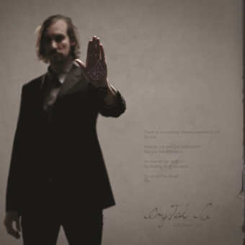
Od 7. februarja do 7. marca 2014 se v Ljubljani s projektom CRYSTAL C predstavlja slovenski umetnik JAŠA.
Gre za diptih občutja, ki se bo raztezal med dvema galerijama Muzeja in galerij mesta Ljubljane. Prvi del, naslovljen It feels like tiptoeing on the edge [of euphoric sense of beauty], bo našel mesto v Kulturnem centru Tobačna 001, drugi, A place where flowers borrow colours [from those who sing], v Galeriji Vžigalica.

***

Soba.

Znotraj nje je druga soba, ki čaka, da se izoblikuje.

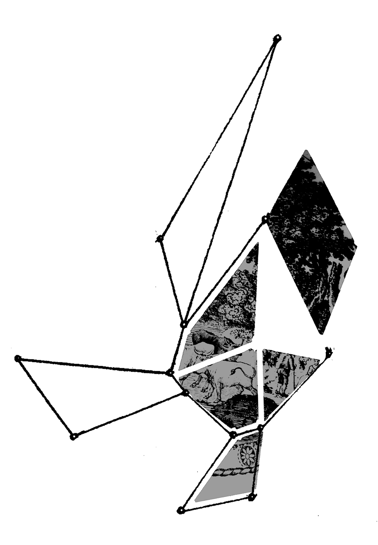: Nekoč sem ujela metulja. Malo je manjkalo, da bi se mi zdrobil med prsti, ko sem mu zašepetala: "Vedno znova se vračam od tam, kjer si rože izposojajo barve tistih, ki pojejo."

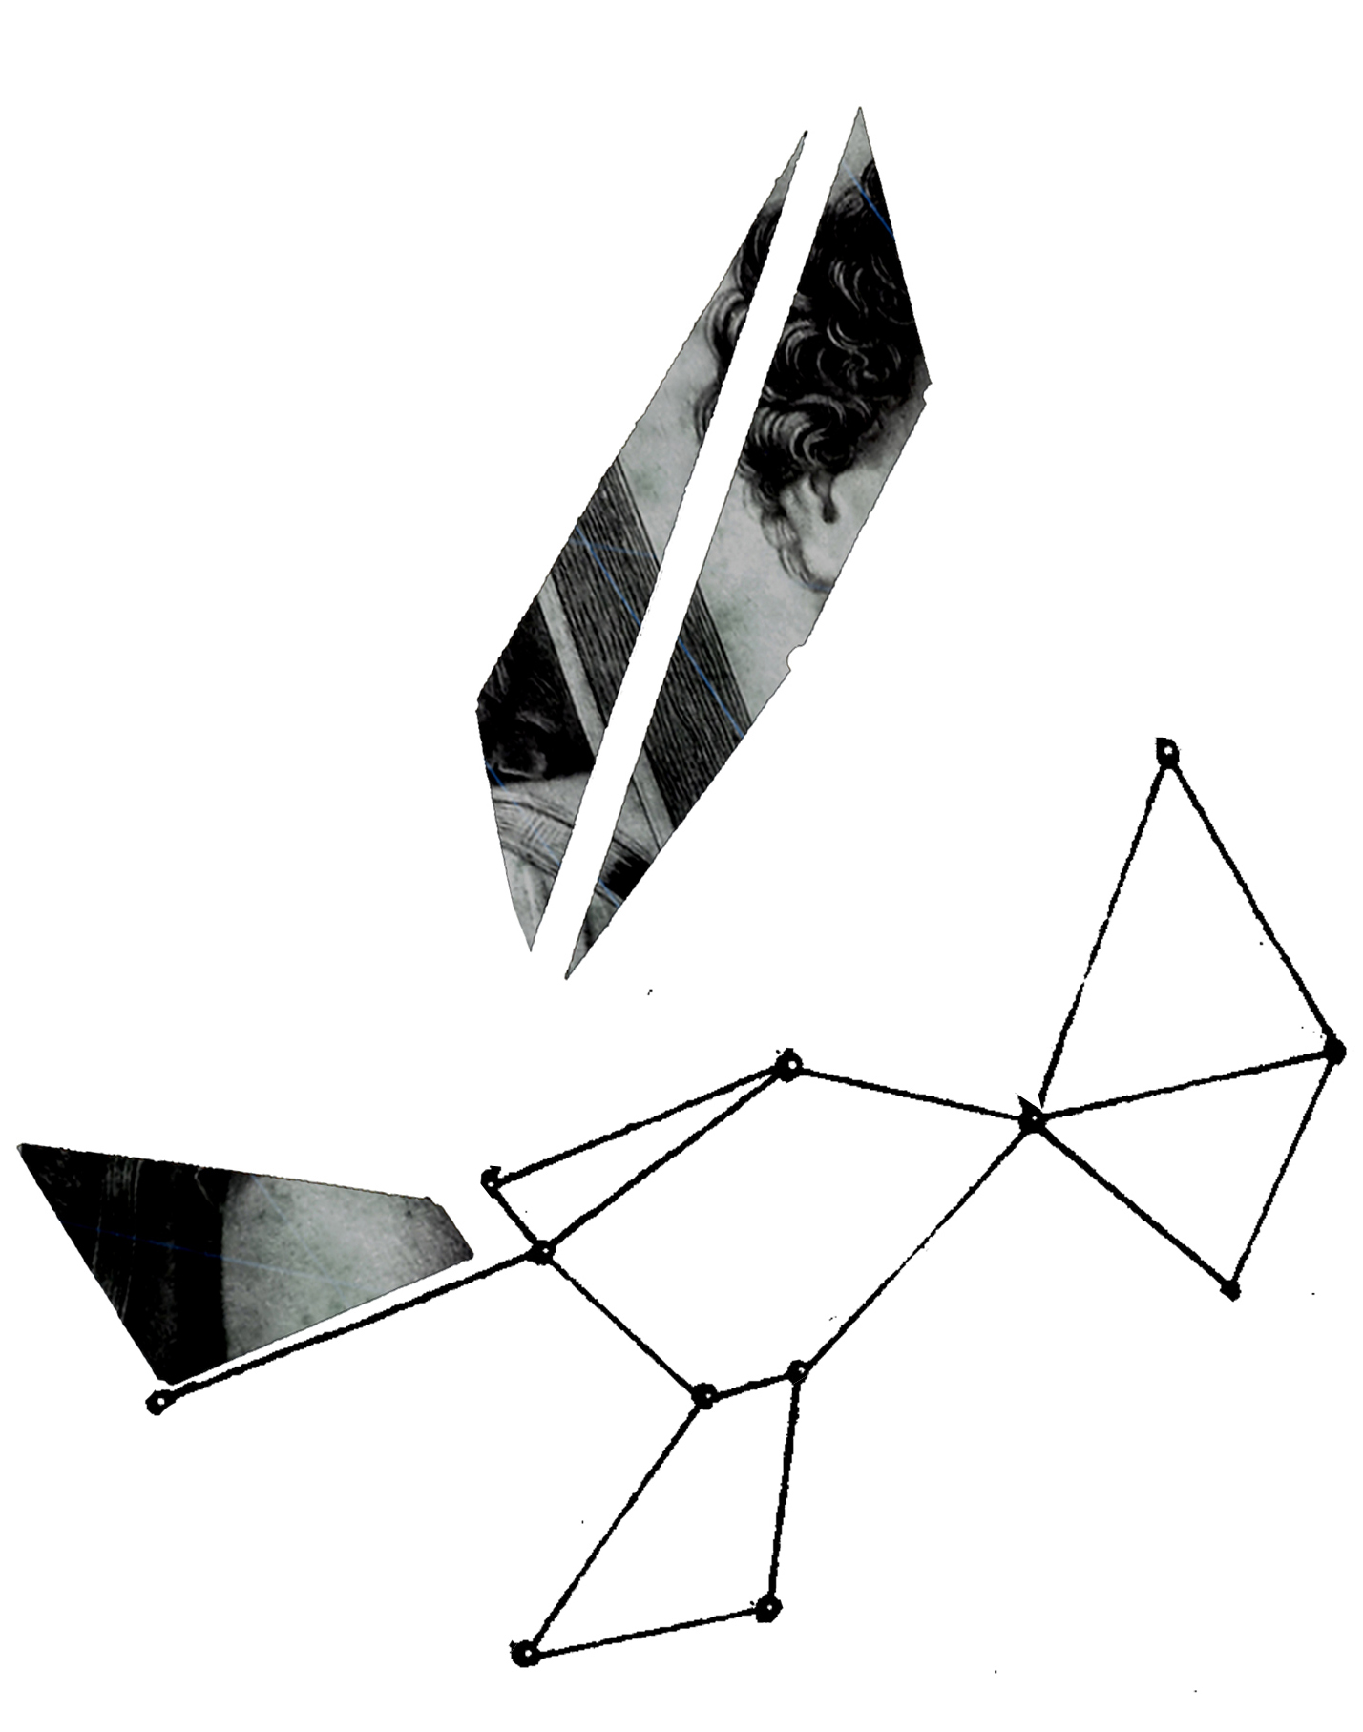: Ko sem pokleknil k tlom, sem prislonil ustnice ob hladno kožo sivega kamna, ki je počival ob mojih stopalih.

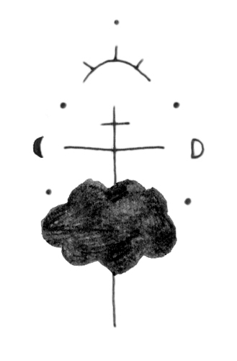: Morda bosta odšla, sem si rekel. Morda bo med njima zrasel gozd.
A melodije bodo ostale.
Morda bosta prerasla obleke, a čevlji bodo opravili svoje.
Pojdi, ljubezen. Ne ustavi se.
Še vedno si ponavljam: "Okleni se sijaja v njunih očeh; povsem mogoče je, da je to najlepša pokrajina, kar jih boš kadarkoli videl."
Desetletja kasneje se je moja koža spremenila v gobe. Glava je postala pest gline in volja se je prelevila v belo zastavo, v velik kos svilenega blaga, ki poplesava v vetru.
Moji zobje so tipke srednjeveških orgel, renesančnega klavirja, takšnega, na kakršnega je igral Bach ... slišiš ... slišiš njegov zvok? Mikrofon sem si zaril globoko v notranjost trebuha, bližje središču, utripajočemu središču, bližje najtoplejši tekočini v centru zemlje.
Tisto, kar je ostalo od mene, obrnjeno navzven kot žep, je nežno oprhala agua de vida.
Pil sem zlato.
Si kdaj videl aluminijaste odlitke mravljišč? Podobni so strukturi, ki je nastala, ko sem spil zlato in je kalup izginil. Vsi v enem, kot eno telo, hodimo, povsem mirno, a ritem naših korakov grmi v oblakih, ustvarja [presunjive] strele ... risbe na nebu."

Zapiski: črni bazen zavesti (ne pozabi ga temeljito preučiti). Beli oblaki mojih sanj.

Temen, temno vijolični trikotnik še vedno visi v zraku.

besedilo projekta, avtorja JAŠA in Nina Vidrih

***

O UMETNIKU

JAŠA (Mrevlje-Pollak, 1978, Ljubljana), pogosto sodeluje z drugimi umetniki, Crash in Progress 1999−2005 (Giorgio Andreotta Caló, Simone Settimo, Peter Furlan & Martina de Lugnani), in v zadnjem obdobju z umetniki, kot so Kalu, Junzi, Nina Vidrih, Mark Požlep, Jyrki Riekki & Meta Grgurevič. Živi in dela v Ljubljani, Benetkah in New York-u. Sodeluje z Galerijo On Stellar Rays (New York) in Roso Lux /WEARE.

Najpomembnejši samostojni projekti:
CLOUD TAILOR (in Jyrki Riekki), Sinne, Helsinki, 2013
APNEA’S RHAPSODY, Galerija On Stellar Rays, New York 2012
SINGLE, Galerija A+A, (kustos Juan de Nieves), Benetke, 2012
THE LOVEST, Moderna galerija, Ljubljana 2010−2013

Najpomembnejše skupinske razstave in projekti v zadnjem času:
Galanterie Mécanique/Fil D'argent (projekt Mete Grgurevič & Urše Vidic) z LEFTFINGER in BOWRAIN, 30. GRAFIČNI BIENALE: PREKINITEV, Mednarodni grafični likovni center, Ljubljana, 2013, kustosinja Deborah Cullen
The Accademie Pavilion, 54. BENEŠKI BIENALE, 2011, Benetke
U3 - 6. TRIENALE SODOBNE UMETNOSTI V SLOVENIJI: IDEJA ZA ŽIVLJENJE. REALIZEM IN REALNO V SODOBNI UMETNOSTI V SLOVENIJI, Moderna galerija, Ljubljana, 2010, kustos Charles Esche

***

JAŠA: CRYSTAL C
7 February–7 March 2014

Tobačna 001 Cultural Centre: It feels like tiptoeing on the edge [of euphoric sense of beauty]
Vžigalica Gallery: A place where flowers borrow colours [from those who sing]

Opening of the exhibitions
The opening of the exhibition at Tobačna 001 Cultural Centre will be on Friday, 7 February, at 7 pm and will be held until 8.30 pm. The opening will continue at Vžigalica Gallery at 8.30 pm and will last until 11 pm.

Accompanying programme
On Tuesday, 11 February, we would like to invite you to attend the public guided tour of both exhibitions starting at Tobačna 001 Cultural Centre at 5 pm. Jaša and the curator of the project, Michele Drascek, will guide you through the exhibitions.
On Thursday, 6 March, at 6 pm we would like to invite you to attend the closing event at Vžigalica Gallery.

From 7 February to 7 March 2014 Slovenian artist JAŠA will present his project entitled CRYSTAL C in Ljubljana. The project is conceived as a diptych of a feeling and will be presented in two galleries of Museum and galleries of Ljubljana. The first part, entitled It feels like tiptoeing on the edge [of euphoric sense of beauty], will be presented at the Tobačna 001 Cultural Centre, second, A Place Where Flowers borrow colors [from Those WHO sing], at the Vžigalica Gallery.

***

A room.

Inside this room, another room is about to take its shape.

: I caught a butterfly once, it almost crumbled between my fingers as I whispered: "I cannot help myself but to come again, from a place where flowers borrow colours from those who sing."

: As I kneeled to the ground I pressed my lips on his cold skin, this grey stone resting at my feet.

: They might leave, I say to myself. They might grow a forest in between. But the melodies will remain, the clothes might grow old and tight, but the shoes will do their job. Walk my love, never stop. I keep telling myself: "Cling to that shine in their eyes; it might be the most beautiful landscape I will ever see."

Decades later, mushrooms became my skin. My head became a fist of clay and my will turned into a white flag, a large piece of silky fabric dancing in the wind. My teeth are the keys of a medieval organ, a renaissance piano, the one Bach used to play … can you ... hear the sound? I pushed the microphone deep down into my stomach; only to be closer to the core, the pulsating red core, the warmest liquid in the center of the earth. Gently showering me, what was left of me, all turned inside out like a pocket, was agua de vida. I drank gold. Have you ever seen the anthill aluminum casts? This is what it looked like when I drank gold and the cast disappeared. All in one, one body, we walk, calmly … but the rhythm of our feet thunders in the clouds, creating devastating bolts of lightning … drawings in the sky.

Notes: black pool of my consciousness (remember to look into it thoroughly). White clouds of my dreams.

A dark, deep dark purple triangle keeps on hanging in the air.

text for the project, authors JAŠA and Nina Vidrih

***

ABOUT THE ARTIST

JAŠA (Mrevlje-Pollak, 1978, Ljubljana), frequently works in collaborations, with Crash in Progress from 1999−2005 (Giorgio Andreotta Caló, Simone Settimo, Peter Furlan & Martina de Lugnani), and recently with Kalu, Junzi, Nina Vidrih, Mark Požlep, Jyrki Riekki and Meta Grgurevič. He lives and works in Ljubljana, Venice and New York. He works with On Stellar Rays Gallery (New York) and Rosa Lux /WEARE.

His most important solo projects:
CLOUD TAILOR (with Jyrki Riekki), Sinne, Helsinki, 2013
APNEA’S RHAPSODY, On Stellar Rays Gallery, New York, 2012
SINGLE, A+A Gallery, (curator: Juan de Nieves), Venice, 2012
THE LOVEST, Museum of Modern Art, Ljubljana 2010-2013

The most important recent group exhibitions or projects:
Galanterie Mécanique/Fil D'argent (project by Meta Grgurevič & Urša Vidic) with LEFTFINGER and BOWRAIN, 30TH BIENNIAL OF GRAPHIC ARTS: INTERRUPTION, The International Centre of Graphic Arts, Ljubljana, 2013, curator Deborah Cullen
THE ACCADEMIE PAVILION, 54th Venice Biennial, 2011
U3 - 6TH TRIENNIAL OF CONTEMPORARY ART IN SLOVENIA: AN IDEA FOR LIVING. REALISM AND REALITY IN CONTEMPORARY ART IN SLOVENIA, Museum of Modern Art, Ljubljana, 2010, curated by Charles Esche

***

Sodelujoči / Collaborators:

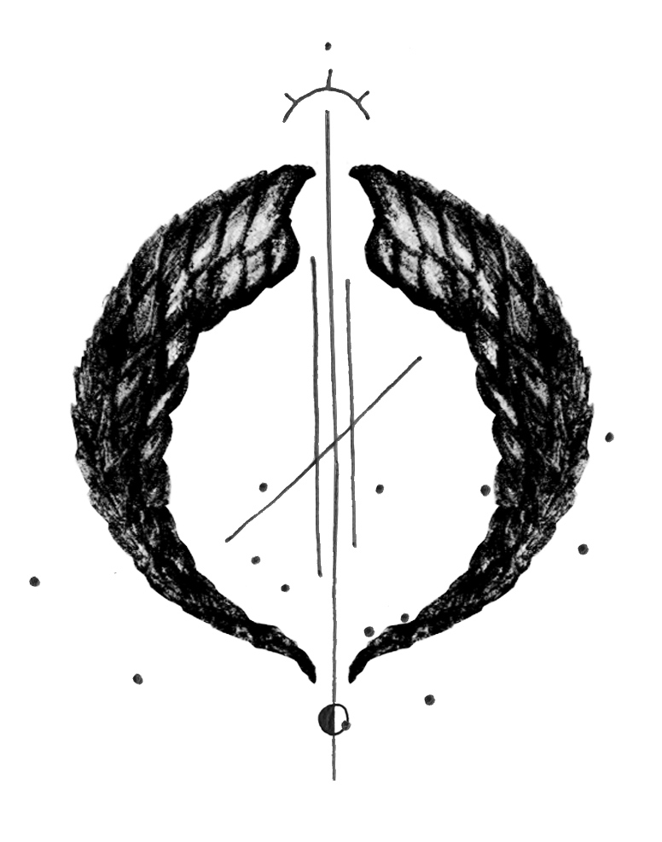
JAŠA, Michele Drascek, Nina Vidrih, Meta Grgurevič, Otto Urpelainen, Erik Vidmar, Griša Šoba, Luka Tratnik, Matevž Klanjšek, Tine Grgurevič, Nika Ravnik, Ljud, Lux & Junzi.

Koprodukcija / Co-producer:
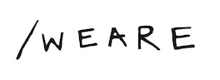

Spletna stran projekta / Project's website: www.crystal-c.org.

Lokaciji razstav / Exhibition locations:

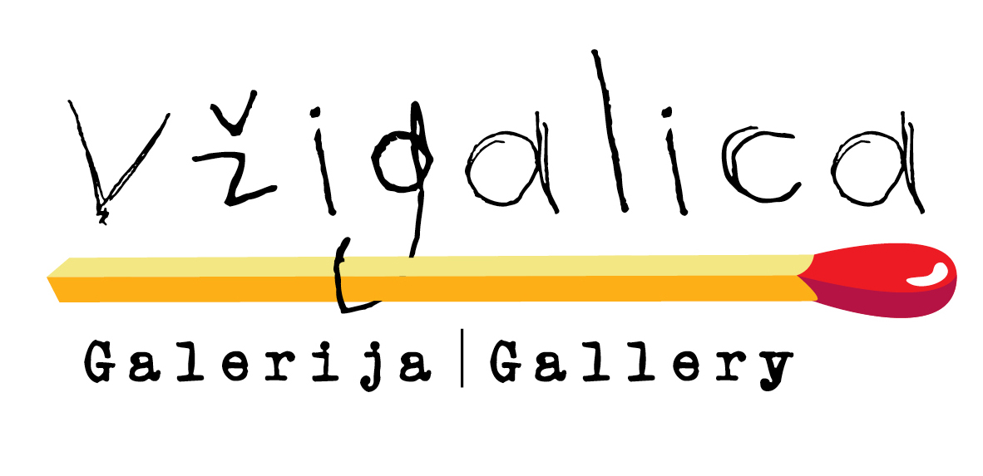


Projekt je podprla / This project was supported by:


Podpornika projekta / Supporters of the project:


